First inbuilt modules in node is

1. http  
   1) create server  
   2)listen to that server  
   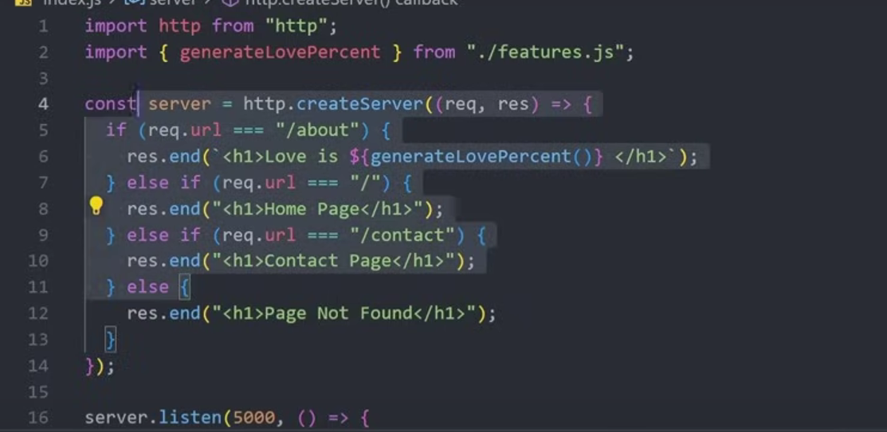
2. fs  
     
   1)readfile



2)readfilesync

const home fs.readFileSync("./index.html");

1. os
2. path

1)Authorization

1. cookieparcer-

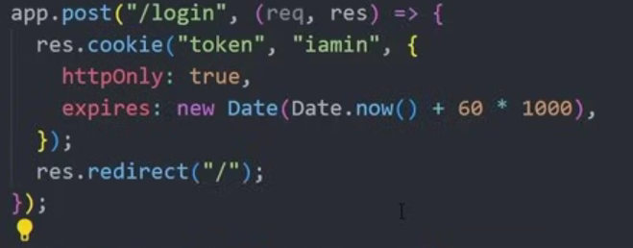  
  
logout-  
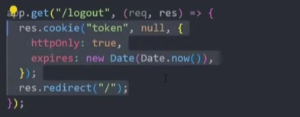

By middle ware

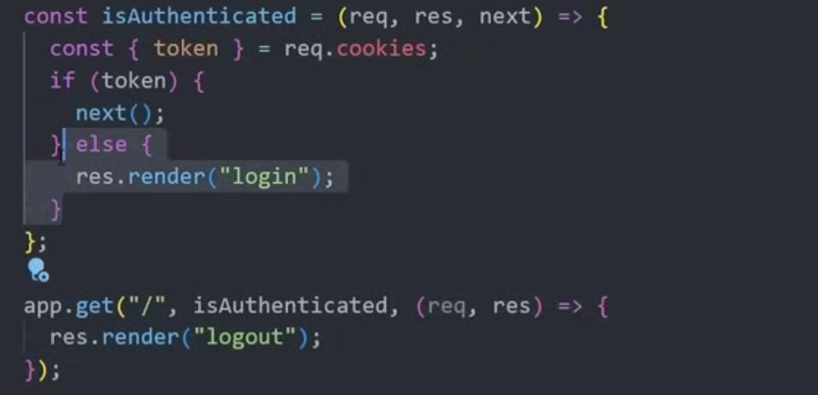  
  
2) JWT  
adding jwt in token  
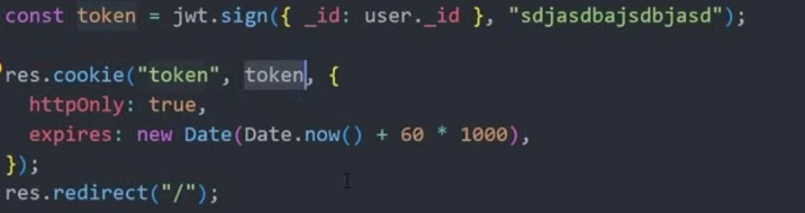

VERIFYING THE ADDITION  
